Acceptable Seedling Specifications (Pinus Radiata)

Industry accepted nursery practices are to be used to produce the maximum number of Seedlings possible to the following standards: -

- Height - the stem length measured from the surface of the nursery bed to the top of the Seedling shall be between 25cm and 35cm;
Topping cut
HEIGHT MEASURE
RCD measure
Measure height from the Root Collar Diameter (RCD) to topping cut (growing tip). Round to the nearest 0.5cm.

- Topping - if the Seedlings require topping to maintain height specifications and hardness and if more than one topping is required then each successive topping will be below the previous one. Topping will be done at least five (5) weeks before time of harvesting and at a time to ensure bud development at the top with significant bud elongation;

- Root Collar Diameter - The minimum root collar diameter shall be 5mm;
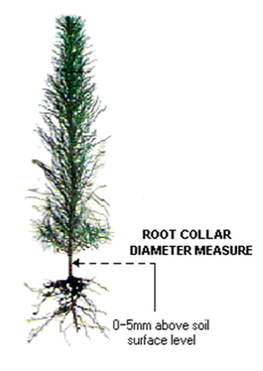

Measure the stem diameter at the root collar, for Seedlings this is located at 0-5mm above soil surface level. If the soil surface level is difficult to locate, use a point half way between the lowest foliage remnants and the first lateral root. Round to the nearest 0.5mm.

Root Collar Diameter Measure

0-5mm above soil surface level

- Root Structure - the Seedling roots must have visible fibrous root development;

- Root Trimming - the Seedlings should be hand trimmed to ensure a minimum root length of 60mm with none longer than 100mm (from the point of root initiation to the tip of the roots);

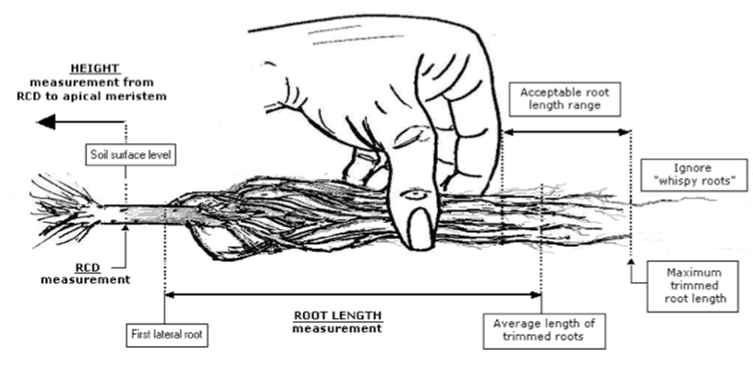

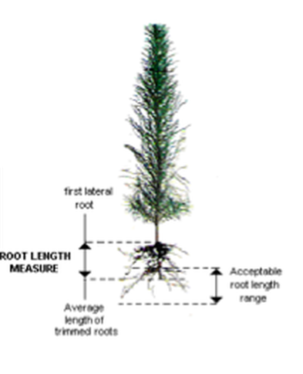
ROOT LENGTH MEASURE
Average length of trimmed roots
Acceptable root length range
First lateral root
- Double / Multi Leaders -

At time of harvesting – Seedlings with 2 leaders originating only from the upper half of the stem will be accepted if there is a dominant leader. Seedlings with greater than 2 leaders will be rejected;

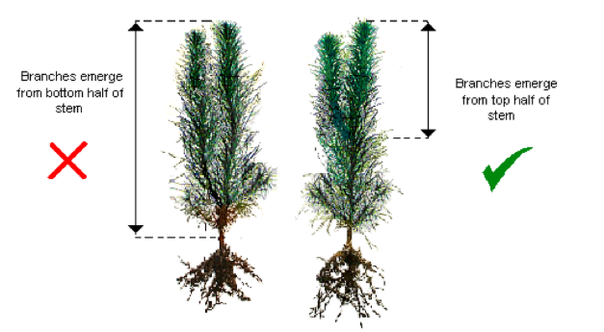
Branches emerge from bottom half of stem
Branches emerge from top half of stem

- Stem Straightness - Only Seedlings with straight stems will be accepted. A Seedling is rejected when it is not possible to plant in an upright position (stem or roots deviate more than 30mm from vertical);

Stem or root tip deviates less than 3cm from vertical

Stem or root tip deviates more than 3cm from vertical

3cm or LESS
GREATER than 3cm
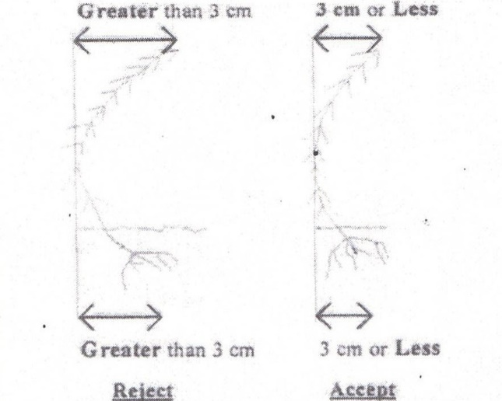
3cm or LESS
GREATER than 3cm
Reject Accept

- Vigor - All Seedlings are to be in a healthy condition at time of harvest. Those with stripped foliage, damaged stems or roots, and/or have evidence of disease will be rejected;

- Lifting and Handling - Seedlings will be handled in such a way as to ensure minimal loss of tertiary (feeder roots) and mycorrhiza. Seedlings will be packed immediately after harvesting into boxes;

- Seedlings Per Box - There will be 100 Seedlings per box;

- Ordering - Seedlings will only be lifted after having received an order. Each order will be lifted one to two working says before dispatch unless special provisions have been arranged for that order.

